Overview
In November 2021 we secured the funding to work with National Citizen Service (NCS) and their UK Year of Service programme (UKYoS). The initiative offers paid, meaningful employment helping young people aged between 18 and 24yrs to engage in community work and help make a positive impact in society whilst also helping young people get world and work ready.
It was success from the get-go, we recruited 15 young people across Dorset to take part in the programme and also supported a further 10 young people in other areas in the south. We partnered the young people up with community organisations such as youth clubs and volunteer centres.
The programme included:

- To kickstart the UK Year of Service the young professionals had a week of induction activity covering reflections for the programme, safeguarding training, 0-25 VCS conference and a day bringing together partner organisations and young professionals to celebrate the start of the programme

- Monthly remote drop-in sessions were provided to keep in touch with the young professionals and gain feedback/give them an opportunity to shape training and support offered. They also had regular/monthly 1:1 sessions, reflecting on their journey and planning with the Youth Employment Team Leader for their next steps

- Our South participants also had access to monthly check ins and regular visits from the Youth Employment Team Leader to ensure there was adequate support. Our partner organisations were brilliant at providing these young people with appropriate training, complemented by additional opportunities through DYA.

- We created a network of support between the young professionals and as a group they supported each other with tasks; linking organisations and sharing social media posts to increase reach online

- The young professionals attended sessions provided by NCS and went on a 2 day residential training event in Swindon. They got a chance to network with other participants from the south of England/UK on the YoS programme. It was a trip filled with networking, meeting new people, sharing ideas and social action.

- We had a team building/celebration day halfway through the project at Weymouth & Portland Adventure coming together to plan next steps and have some fun while learning facilitation skills around leadership and teamwork.

- The Year of Service programme continued until August 2022, but we are really proud of everything our young professionals achieved, from organising Pride events, to arranging an alternative prom and creating exciting project such as VoiceX!

- The success continued with 76% of all the young people recruited going on to further employment or education.

My point of view:
It has been a pleasure working with the all the young professionals and the organisations on UK Year of Service. It has been great seeing the young professionals gain new skills throughout their training and then seeing them put these skills into action at work. The organisations have done a fantastic job mentoring the young professionals throughout their placements giving them all valuable experiences and skills for the workplace.

Feedback from young people
Young person 1: “Taking this role with Dorset Youth Association’s support has given me the safe space and confidence to empower my family to rely on me less and this has been really freeing – I didn’t think I would manage, and this limited my ambitions before. It has also meant I have been able to work in good quality jobs within my local community. I feel like I have a lot more knowledge and have been able to implement that in the work that I do”.
Young person 2: “It has been like a rollercoaster, ups and downs but I’ve made it, it’s been fun, and I’ve loved every minute of it. This experience has given me the confidence to strive and be the best person I can ever be and has now made me so excited to see myself in the future. I don’t have a favourite highlight because I’ve loved it all, the best thing to come from this is my journey and how far I’ve come and just to look back and see how I was feeling at the start compared to how I am now- I can happily say I’m proud of myself!
Young person 3: “I found the training that DYA supplied extremely helpful and practical, and I came away from every session feeling empowered and like I had more tools in my toolkit. It was refreshing to see a model of training that was paid and supported – it made me feel like I was worth investing in”.
Young person 4: “Brilliant, I’m so glad I did it. Everyone has been so supportive and encouraging. It’s my first / longest proper job and I feel like I really lucked out”.

Feedback from an observation of training that DYA delivered with the UKYoS Young professionals
“High member engagement, with good buy-in and positive facilitation, with strong links in the content planning to the Theory of Change
They also mentioned that the level of responsibility given to some members was stretching but clearly provided opportunities for members to test themselves/their skills”.

Statistics for UKYoS in Dorset
15 young people in placements in Dorset
At least 1 young person in each locality of Dorset
10 partner organisations involved
8 or 54% progressing into full time or part time work after UKYoS
5 progressing onto a university degree or part time college course
Total of 87% going onto a positive outcome
Provided 12 training courses totalling to 36 hours of professional development
Statistics for UKYoS in South
10 young people in placements
5 partner organisations involved
6 or 60% progressing into full time or part time work after UKYoS

Organisations who have had taken part

-Blandford youth club
-Verwood youth Club
-Purbeck youth and community Centre
-Dorchester Youth Club
-Dorset youth Association
-Dorset Forest School
-The Horse Course
-Island Community Action
- The Drop-In Portland
-Space Youth Project
The Volunteer Centre Dorset

South Partner organisations:
-Young Devon
-DYS Space
-Young Bristol
-MAYK

NCS National awards

2 young professionals were recognised by NCS at a celebration event.
Nomination 1 & overall winner:

Young person has been acknowledged for the outstanding contribution you have made whilst on UK Year of Service. Your organisation has recognised your specific achievements in the area of Delivering Impact.

Feedback included “… standing out to our judges as the best example of keeping community and citizenship focus on everything they’ve done”.
Nomination 2: & Shortlisted to the final 4

Young person has demonstrated notable leadership skills and qualities; empowering and inspiring others, leading by example and displaying emotional intelligence.

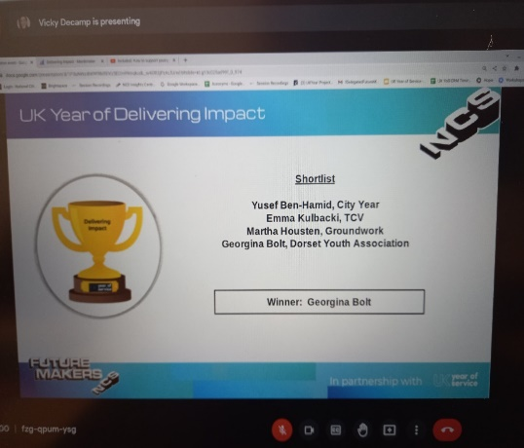

Case studies from partner organisations and how having a young person on board made a positive impact to their organisation
Case study 1: “It brought fresh ideas, and these were often realistic to what’s going on in the world and it helped us to relate to young people and what they are going through. It was great working with them to see how we could turn their ideas into reality in a professional way for our organisation. They were also very able at understanding the young people that we help to support”.

Case study 2: “Very positive impact, having a young person’s perspective has helped us shape some of our projects going forward”.
Case study 3: “Great impact as they were able to build relationships differently compared to our other staff and pick up conversations with the young people. it also helped reassure us that what we were offering at youth club was relevant to what young people wanted”.

VoiceX project
Alisha was another one of our UK Year of Service young professionals and during her placement with us she helped us to develop the VoiceX project. The aim of the project is to capture the voices of young people across the county, to raise the voices of young people so that we can hear their thoughts about where they live, services on offer and the activities that are available to them. This data can then be fed back into the voluntary sector to assist with funding and improvements to services.
We are just starting to roll out the survey by visiting local organisations who are taking part in the Holiday activities & Food programme during the Easter holidays.

Social Media Project
Megan has been one of our UK Year of Service young professionals. Over her 9month placement with us she developed a social media support project to help organisation in the voluntary sector with their social media presence.
Megan “Since starting in November, I have helped a total of 10 organisations with their online presence. Whether this has been to link their Facebook and Instagram accounts, set up a new account for them or to give a detailed workshop on how to effectively use these platforms
One organisation has said Thank you so much for your assistance. You’ve given me the confidence to get to grips with Facebook”. This feedback was really nice to see as it shows that the help, I have given will have a long-lasting effect and will boost the confidence of others to continue on their own.
I have also taken a lead on Dorset Youth Associations online platforms. I have increased our posting schedule to 3 times a week and stayed active on Instagram, Facebook, Twitter and LinkedIn. Within the first 4 months of my work online we reached +449% more accounts than we did the previous 4 months, before I started. This is beneficial as more people were learning what DYA is about and was starting to recognise our content, which ultimately led to more engagement online. In November when I joined DYA, we had 368 followers on Instagram. We now have 590 and this is continuing to grow each day.
Overall, I have enjoyed seeing DYA’s online presence grow and progress over the last 9 months and see the online relationships with other local organisations to flourish. The best part of the social media project is seeing the organisations put into action what I have shown them to do and seeing them have the confidence to continue on their own.

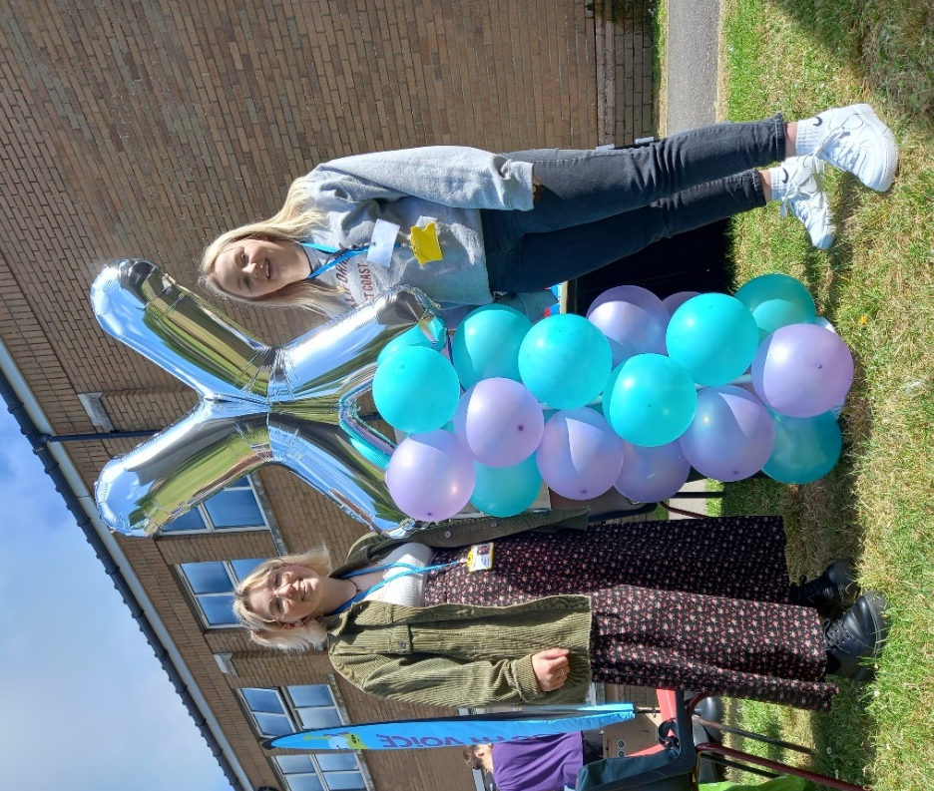
Megan & Alisha -holding a VoiceX stand at Weymouth College’s EqualityDiversity fair

