Dear …………..(insert name of LD Champion),
My name is…………….. I am ……years old and I have a Learning Disability. Please make sure I am on your Learning Disability Register.
Below is some useful information about me.
I would like to have my Annual Health Check.
Please contact ……………..(me / my parents / carer) to arrange an appointment.
I can / cannot come to the surgery for this.
Below are some reasonable adjustments I will need when we meet.
Thank you

(name)
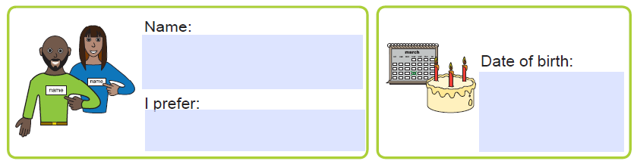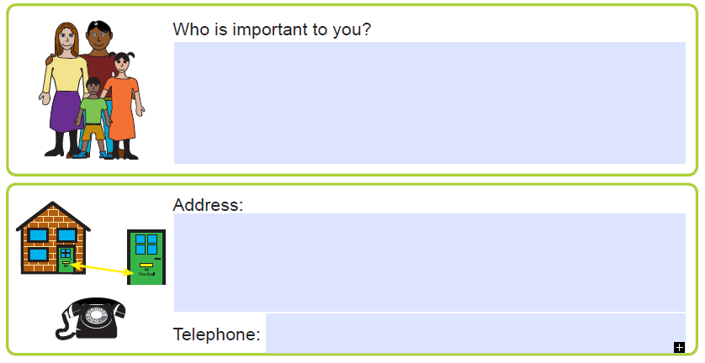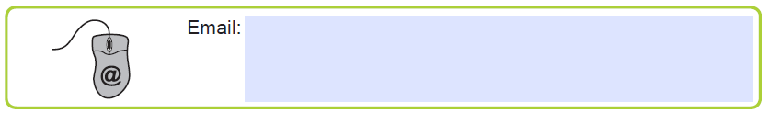

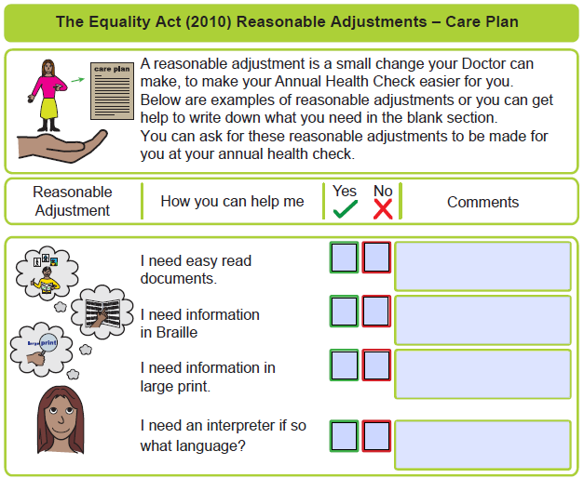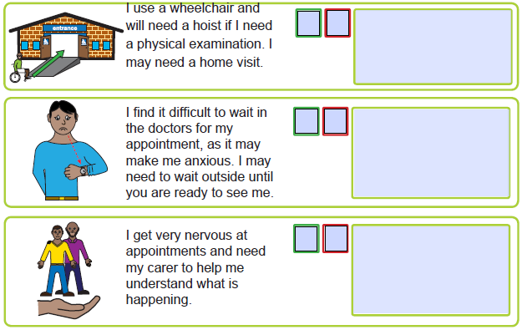
My language is:

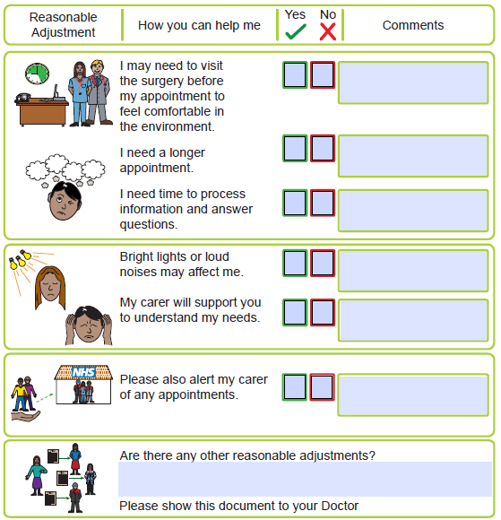

We acknowledge and extend our thanks again to Leeds and York Partnership NHS Foundation Trust for permitting use and modification of their template.

Livewell Southwest is a Community Interest Company (CIC).
Company Registration Number 07584107. Registered in England and Wales.
Registered Office Local Care Centre, 200 Mount Gould Road, Plymouth. PL4 7PY.
Plymouth Community Learning Disabilities Team/FMS/09-2020

