Chesil Locality
Local Alliance Group
Minutes
Wednesday 4th October 2023 – Weymouth College
Meeting Attendees:
Chair: Sue Dafter (Head of Student Services, Weymouth College)
Attendees: Anna Beech (Health Programme Advisor), Charlotte Emery (Community Development Worker WTC), David Harris (Town Council Member), Siobhan Lennon Patience (Parent)
Hybrid: Alice Deacon (Strategy & Lead Chesil Locality), Joey Wormington (Active Dorset), Harriet Laurie (Horsecourse), Sue Rogers (Service Manager Social Care), Karen Wardle (Service Manager Social Care), Sharon Holmes (Libraries), Laura Roberts (Active Dorset), Karen Bidwell (Westfield), Emma Letchford (Horsecourse), Jakki Spencer (Clinical Lead Health Visiting), Esther Elliott (Team Leader W&P CAMHs), Gail Brown (Holy Trinity)
Minutes: Katie Walker
Apologies:
Cllr David Northam, Cllr Jane Somper, Cllr Susan Cocking, David Freeman (NHS Chief), Deb Woodward (Families & Babies), Jane Biscombe (WTC), Katie Slater (Bincombe Primary), Louise Drury, Marie Thompson (REACH/DC), Rachel Folland (Homestart), Richard Howes, Sandra Healey (Dorset Healthcare), Sara Ellis (Wyke Regis Primary), Sarah Stockham (Mental Health), Sharon Mitchell, Sean Holehouse (Service Manager EH&Ed), Dan Parker (Skills & Learning), Sarah Crabb (Social Mobility Commissioner)

No. | Actions from Previous Meeting | For:
Prev mtg | Amanda to write a handover for Relationships and Financial Wellbeing | Amanda Davis
4.1 | Sharon Holmes to share LAG funding application for consideration | Sharon
5.2 | Follow up question from Harriet re: Advertising what LAG is, can anyone can join? | Alice

No | Item Minutes
1 | Welcome, Apologies & Introductions | Sue
1.1 | Sue welcomed everyone to meeting and thanked them for joining us.  Apologies for no agenda as returned from leave today.
1.2 | Due to IT issues at Weymouth College, decided to not do a full meeting, but do key updates and information sharing. | Alice
2 | Matters Arising
2.1 | Was looking at a refresh and a reset. As you know we have 2 LAGS in Chesil as Weymouth and Portland are very distinct and have unique needs, so as of today, Chesil LAG will now be called Weymouth LAG.  Portland LAG now has an independent Chair, Sarah Howard from NHS. Sue and Sarah will work collectively.  As partners that might sit over both we want there to feel like there’s a clear definition between the 2 and we aren’t asking you to do duplicate work. If there are things that connect in both LAGS that we can streamline some of that.  Thanks to Sue, Sarah and Harriet. | Alice
2.2 | Thank you, Harriet, for being vice chair, been fortunate as we are the only LAG with a Vice and it’s really helped to bounce discussions. We are sadly losing Harriet due to her business which means we need a new Vice Chair.  Anyone like to put themselves forward?  Please email Chesil Locality, Alice & Sue if you would be interested being Vice Chair before the next meeting | Sue  ALL
2.3 | Need to discuss how we bring in the children and young people’s plan into the LAG because our LAGS are our local delivery, they are our local implementation of that.  Attach Children, Young People and Families’ Plan 2023 to 2033 to minutes | Alice  Katie
2.4 | Please email chesillocality@dorsetcouncil.gov.uk if you struggle to access the Chesil LAG Teams page, or the Chesil Partnership site.
3 | Family Hubs
3.1 | Has not yet had a meeting with Rebecca Watson to be briefed regarding the Family Hubs.  Katie to give Rebecca Sue’s details to organise meet before next LAG meeting. | Sue  Katie
3.2 | Rebecca Watson is the Project Lead for Family Hubs (FH).  Her and the FH team have been talking to Chesil Locality about timelines and what that might look like in Weymouth and on Portland.  Invite Rebecca to next LAG meeting to give a full briefing to you all, including timelines and when things might be coming up because we will need you.  They are thinking 3 family hubs. Thinking one on Portland, one in Weymouth central area and one out at Littlemoor. To roll out around late 2024 and those partnership arrangement and discussions will be happening throughout the period.  You as the local alliance group, will play a key part in the governance and oversight of the family hubs and be thinking about their performance in terms of whose there and accessing etc.  David: How big of a space we looking for the Family Hub?  Alice: If you got any ideas, please share. Can’t be just one or two rooms as we need to accommodate many partners.  David: Dorset Care Centre in Southill are leaving their space so there is a Dorset Council Space available.  Gail: Holy Trinity is always open to hosting any pop up hubs if possible  David and Gail to email Rebecca regarding buildings/space for Family Hubs.  rebecca.watson@dorsetcouncil.gov.uk  Anyone else with ideas, please email Rebecca. (email address address) | Alice  Gail & David  ALL
4 | Update on Pathfinder – Social Care Review | Alice
4.1 | We are one of the first 3.  Will make this an agenda item for next meeting.  We have 3 work streams that are running family help, which Alice is leading.  1: Section 10 (targeted early help) & section 17 (SYN) into one service which would be family help.  2: Children Protection  3: Safeguarding partners which is looking at the partnerships we are working with, and the family networks work stream, which is around family group, conferencing, family network meetings, kinship care and other aspects.  In co production phase at present.  Families first for children (FFC) pathfinder programme and family networks pilot (FNP) - GOV.UK (www.gov.uk)  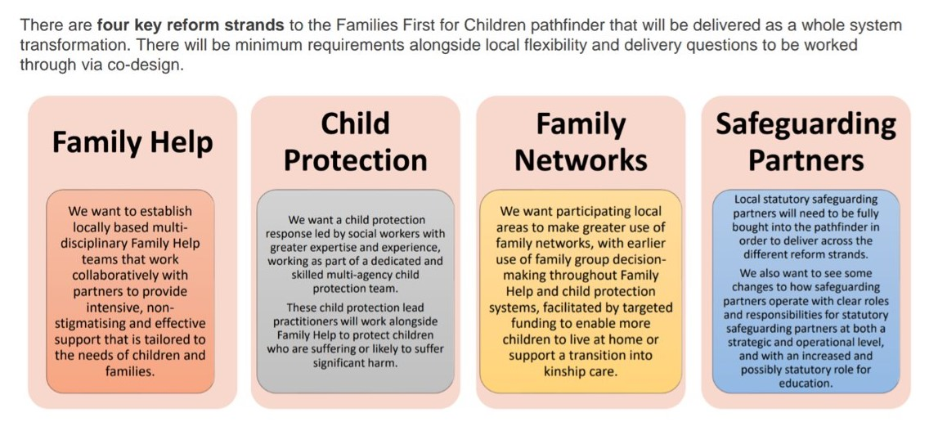 | Katie
5 | Police Updates | Sue
5.1 | Chair and vice have requested that we continue to get regular updates from the police.  Sadly, no representation here today.  Sue asking Alice to follow this request up for LAG meeting to have police attend so we can hear what is happening locally. We feel this is an essential part of the group that is missing since David Parr went on secondment. | Alice
6 | Reboot of Weymouth LAG | Harriet
6.1 | Sue and Harriet spoke about what they want to see from the Weymouth LAG meetings.  1: Clarity on the overarching strategic alliance priorities as we are meant to sit under.  2: Our response to those priorities, how can we have that local impact based on those priorities and how does our local knowledge and network support them and what do we need to have that impact.  3: Our response to Strategic Alliance updates.  4: Like updates from the Strategic Alliance or elsewhere to include things like Family Hubs the ICB. The CAHMs transformation.  5: The change to localities which were formally the Family Partnership Zones.  6: The Harbour Project in Weymouth for high need children.  Other partners might know about other things that are going on or county wide that we should keep abreast of.  7: Update from LAG Chairs meetings  8: Updates from local agencies to include local data, problem hotspots, problematic trends, etc - DC, NHS (inc CAMHS), Education, Housing, DV and Police update (have we missed any of the SA agencies?)  9: DYA (VCS) update  10: Networking and information sharing  If you have any other agenda items you would like to see included, please email Sue and Alice. Sue_dafter@weymouth.ac.uk and alice.deacon@dorsetcouncil.gov.uk
7 | LAG Funding Applications | Katie
7.1 | Link to apply for LAG funding in Dorset.  Local Alliance Group funding request Chesil (office.com)
7.2 | Due updates from some of the funding applications.  Katie to email requesting feedback  Gail tried to give update, but sadly poor connection. Was positive feedback  Gail to email Chesil Locality with update on Walking Bus for Holy, Conifers and Wyke Regis. chesillocality@dorsetcouncil.gov.uk  Nola did a report for Dorset Council.  Sue/Nola to submit feedback report needed with application. | Katie  Gail  Sue
8 | AOB – Partner Updates – Date for Next Meeting | Sue
8.1 | The CAHMs transformation has been significantly slowed down whilst they properly build a business model. Going to have smaller focused ongoing and people already involved should have received an email to see if they want to be involved in these groups.  A few things that will start happening more immediately like the crisis cafes etc.  The workforce are indicating that actually they need to be able to have the transformation model so they know what pathways they are following as well as what pathways they are signposting people so they get the right support.  Katie to share Esther’s email to Sue | Esther  Katie
8.2 | At Tumbledown we had a Forste School, sadly person it has left and we need a replacement.  We are wanting more young people looking into climate change. Is there a way we can encourage Weymouth Schools to get involved, get the message to schools?  Katie: The Head Teachers meeting (unsure who chairs) or email Sharon Peel & Richard Howes who attend this who are Education Specialists for Chesil Locality.  Katie to email Sharon & Richard and cc David Harris. | David  Katie
8.3 | Is there anybody that works with under 18 year olds, especially vulnerable ones that have heard they have been approached by or know of exploitation, grooming regarding the barge and the influx of extreme far right and extreme far right propaganda and leaflets? If so, please can you let me know. | Sue
8.4 | Next Meeting  Prioritise being face to face as it works better, but we’ll always still commit to offering the hybrid option.  Monday 27th November 2023 13:0pm – 1:30pm  At Weymouth College/Hybrid
 | Free to Network with LAG members

