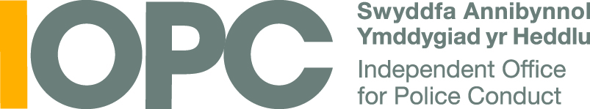

About the application

Please read these notes carefully before filling in your application.

- What is the IOPC Youth Panel?

The IOPC Youth Panel gives young adults a real voice and opportunity to influence and change the police complaints system across England and Wales. As a panel member, you will have a key role in helping support, challenge and inform the work of the Independent Office for Police Conduct (IOPC).

This is an important role – your voice matters in helping the IOPC make sure they listen to young people and consider your needs in relation to police complaints.

The youth panel was set up in 2018 and has made a huge impact since then. The panel has helped shape the IOPC’s strategy, staff recruitment, publications and campaigns.

The panel has also gathered and published the views of thousands of young people across England and Wales through workshops and an annual survey. Most recently, the panel has delivered youth-led workshops with police officers across the country.

- Who can join the youth panel?

We are looking for people aged 16-25 years from a diverse range of communities who are a resident anywhere in England and Wales. This role is open to anyone who is interested and keen to apply.

In total, we want to recruit approximately 15 young adults to join the panel. The total group will be up to 30 young people, including some who were involved in the panel in 2022-23.

We are looking for people who are team players and willing to get involved with all the activities of the youth panel. We would particularly like to recruit young people from different backgrounds, including those from underrepresented groups, and those who may have direct personal experience with the police and the criminal justice system.

- If I join, what will I have to do?

Between July 2023 and April 2024, members of the youth panel will:

- take part in youth panel meetings (July, September, November and February). At these events, panel members will take part in creative and advisory work with the IOPC. In these sessions you will develop skills, come up with creative ideas, and review the progress of the project.

- join subgroups to work on priority areas for the IOPC. You will work closely with IOPC departments such as Communications and Human Resources who need your help to deliver new projects and campaigns. These subgroups will help design and plan activities to reach young people and increase confidence in the police complaints system.

- play a leading role in designing and running youth engagement events across England and Wales by helping plan and run events across England and Wales to help to raise young people’s awareness of the police complaints system, as well as gathering their views.

- become an influencer with the IOPC, police and other stakeholders,
sharing your views, findings and recommendations with key officials from the IOPC, police and partner agencies. You will have opportunities to help to lead workshops with police officers, and present the youth panel’s work at important meetings and events regionally and nationally.

- What will I get from being part of the youth panel?

You’ll have the opportunity to:

- discuss issues with decision-makers as you meet key officials from the IOPC and other partner agencies at youth panel events and help them to understand what young people in your peer group think about police complaints.

- develop your skills and experience, which you can include in your CV and highlight in applications for further/higher education or employment.

- become an ambassador for other young people by helping to give a voice to young people in your area and getting their views heard.

- meet a great new bunch of people as you work with panel members, young people from across England and Wales and work alongside professionals from lots of different organisations.

- make a real difference by creating change. The panel’s work has already changed a lot of things at the IOPC and with police forces. The work you do as a youth panel member can and does make a real difference. If you want to help young people’s voice be heard and influence change, this is a great role for you!

- How do I apply?

Please fill in the application form and email it by Friday 2nd June to paris@leaders-unlocked.org

If you are under 18, you must also fill out the section for your Parent /Guardian /Carer. All youth Panel members under the age of 18 will be asked to bring along a signed consent form to the first event.

6. What happens next?

Please email your completed application form by Friday 2nd June 2023 to paris@leaders-unlocked.org

After the deadline, we will carry out telephone interviews with shortlisted applicants. All applicants will be informed of the final outcome by the end of June.

If you have any questions please contact paris@leaders-unlocked.org

We look forward to receiving to receiving your application!

