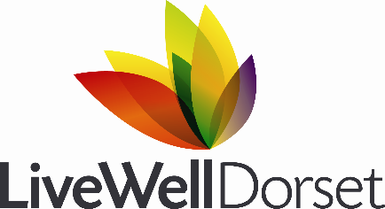

LiveWell Dorset is a health improvement service provided by Public Health Dorset on behalf of BCP and Dorset Council.
The service provides free health and wellbeing support to anyone over 18 who lives in Dorset to lead healthier lives by quitting smoking, managing their weight, moving more and drinking less alcohol. This is achieved by combining traditional health lifestyle services with evidenced based behaviour change interventions in a number of ways including:
- Healthy lifestyle assessment and advice.
- 1:1 LiveWell Coaching over the telephone.
- Connecting people with local opportunities such as weight loss services, stop smoking services and physical activity groups.
- Helping health professionals to support people to take the next step to improving their health, through delivering behaviour change skills training.

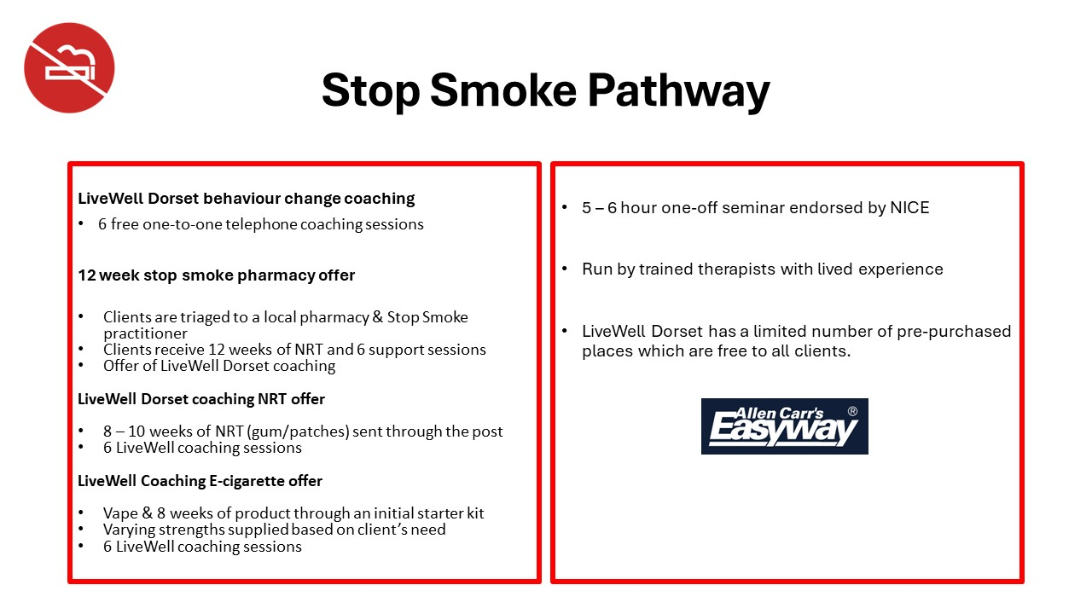
Our Pathways:

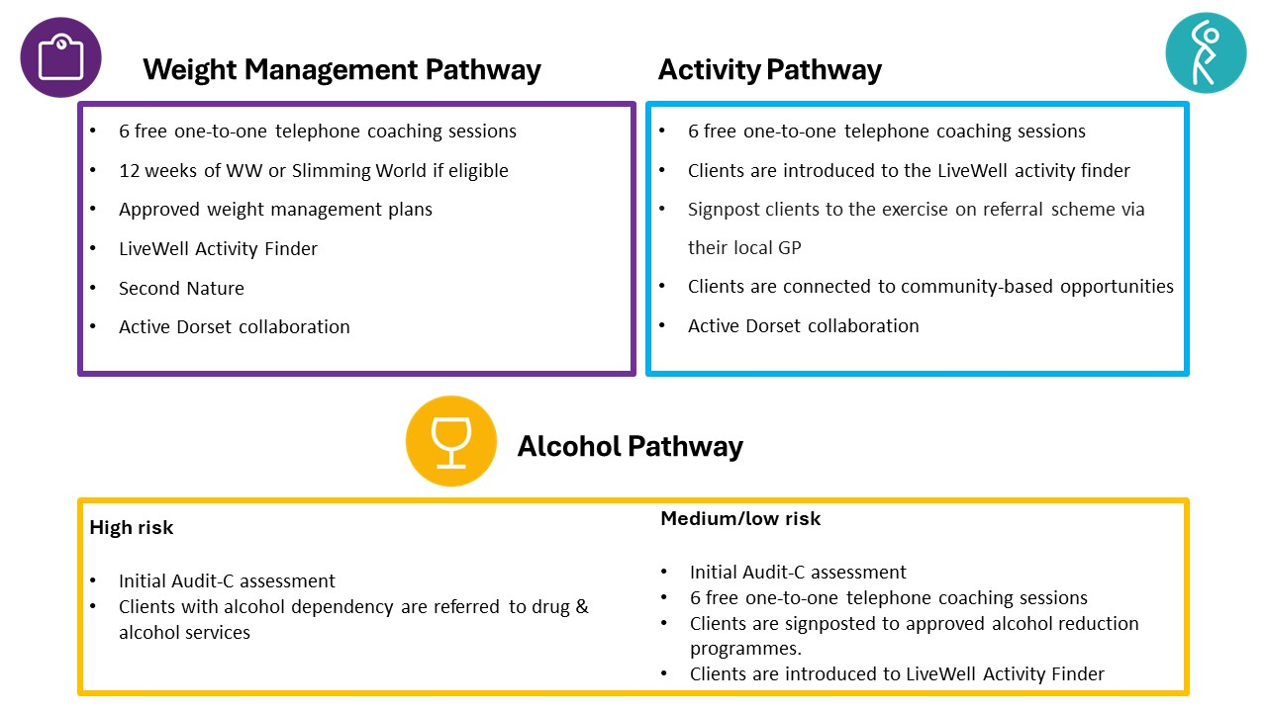

As well as supporting individuals, LiveWell Dorset aims to be a valued system partner; leading system change and supporting organisations and communities to consider their roles in improving health outcomes of the people of Dorset.
Using our expertise in behaviour change, LiveWell can deliver a range of interventions within organisations that support others to initiate lifestyle change including:
- Meet with you to provide an overview of the LiveWell service.
- Deliver free RSPH accredited training to build the knowledge, confidence and skills of your employees to look after their own health and to support others.
- Arrange free NHS targeted health checks at your workplace for eligible staff.
- Run pop up stands and provide printed and electronic material.
Further details of the virtual courses can be found here: LiveWell Dorset Events | Eventbrite.
If you would like to arrange for a member of the training team to provide an overview of the LiveWell service or deliver closed group training please email the training team: training@livewelldorset.co.uk

